 | Neighbourhood Policing Team
  Your next Neighbourhood Meeting is:
  Windermere Parish Council:
  Wednesday 2nd Sept 2009 at 7pm
  Wednesday 16th Sept 2009 at 7pm
  Monday 28th Sept 2009 at 7pm
 | Meet Your Local Officers |  | 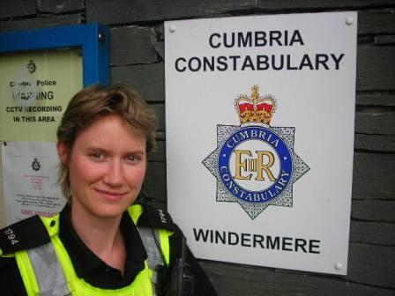 |  | 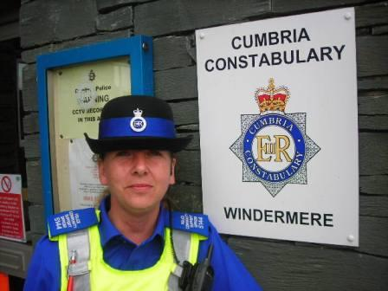 | 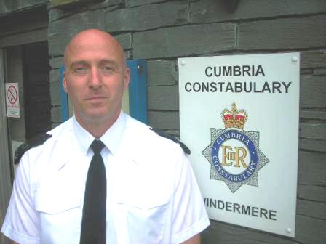
 | PC 1794  Rebecca Hunter | Windermere Town
 | PCSO 5144  Sarah Blacow | Windermere Town
 | Sgt 316  John Stephens | Windermere
 |  |  | PC 1794 |  | PCSO 5144 | SGT 316
 | Contact Us |  | Your Priorities - What you told us
 | Telephone: 0845 33 00 247 ext 4208  In an Emergency dial 999  Email: lakesNPT@cumbria.police.uk  CrimeStoppers: 0800 555 111 |  | After completing a KIN survey Anti Social  Behaviour came out as our number one priority.
 | Your Priorities - What we did |  | Crime In Your Area - Follow Up
 | Windermere Town:  PC Hunter and PCSO Blacow have run many diversionary tactics in our area to encourage positive behavior in young people and reduce incidents of anti-social behavior. These include a football club run with Young Cumbria and a youth Disco held at term ends. Diversionary days out include Army camps to give local youths chance to try something new and positive and to encourage beneficial interaction with the local neighbourhood policing team. We have encouraged local young people to get involved with fund raising for the Lions club which they did on the 8th and 9th of August. The Lions intern will help with funding for local youth project.  PCSO Blacow will again be out with SLDC this coming month to encourage dog owners to be responsible for there dogs and prevent dog fouling.  She is also distributing message in a bottle containers for anyone who thinks they would be useful.  These are small containers, which are placed in the fridge which have all the persons detail e.g. medication and emergency number. A sticker is placed on the outside of the fridge so any member of the emergency services can retrieve it for the vital information it stores.  In conjunction with connection we will be holding a coffee morning at the Marcheasi. We will have our local crime prevention officer to give a talk and answer any questions. Also some pupils from Lakes school to encourage interaction between the generations. The event is on 29th September from 1 till 3. All welcome.  They have also started new Neighborhood Watch schemes in the area and are encouraging the creation of more.  If you require a message in a bottle of any information or help please don’t hesitate to contact us on  0845 33 00 247 |  | CRIMEMAPPING:  Crimemapping is a system of looking at the previous 3 months level of various crimes in comparison to the same period the year before:  Overall the crime figures have stayed the same. We have had one burglary and one robbery both are under investigation at the moment with some leads.  We have had one violent crime reported in the last month.  Anti social behavior has again seen a significant drop. We have run diversionary tactics with the local youths Which have included running stalls for the Lions to fund raise for charities near and far.  Windermere has seen a large increase in tourist with great draws like the Air Show and the both Lions Weekend.
 | Your Priorities - What we did |  | Crime In Your Area - Follow Up

